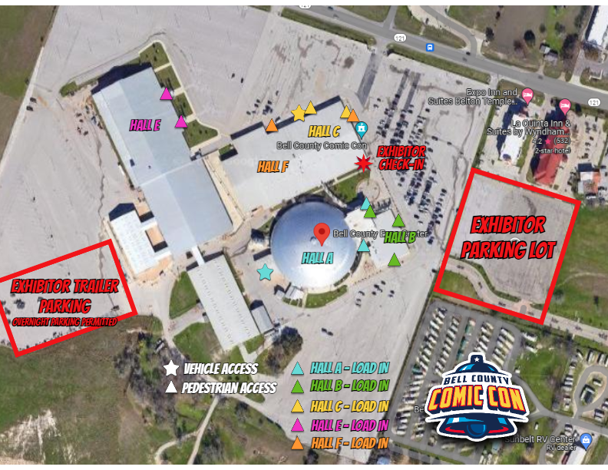
EXHIBITOR PARKING LOT & LOAD IN
All Exhibitors should park in the Exhibitor Parking Lot on Convention Days (except for those with ADA placards).


Any large trailers or oversized vehicles should be parked in Exhibitor Trailer Parking. Overnight parking for trailers or oversized vehicles is allowed in this space.

